x <- readline("Enter a Number : ")

x <- as.integer(x)

if (x %% 3 == 0) {

cat(x, "is a multiple of 3\n")

} else {

cat(x, "is not a multiple of 3\n")

}

OUTPUT:

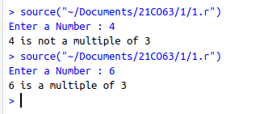

x <- as.integer(readline("Enter a Number: "))

y <- as.integer(readline("Enter a Number: "))

z <- as.integer(readline("Enter a Number: "))

if (x > y && x > z) {

cat(x, " is Greater!\n")

} else if (y > z) {

cat(y, " is Greater!\n")

} else {

cat(z, " is Greater!\n")

}

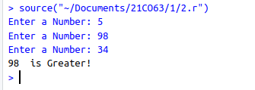

op1 = as.integer(readline("Enter the Operand 1 : "))

op2 = as.integer(readline("Enter the Operand 2 : "))

opr = readline("Enter the Operation : ")

switch (opr,

"+" = cat("Result = ", op1 + op2),

"-" = cat("Result = ", op1 - op2),

"*" = cat("Result = ", op1 * op2),

"/" = cat("Result = ", op1 / op2),

"%" = cat("Result = ", op1 %% op2)

)

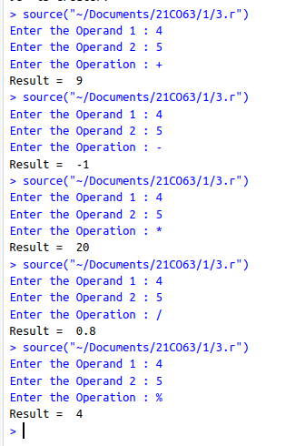

ch <- readline("Enter an alphabet: ")

c <- ch

ch <- toupper(ch)

if (ch >= "A" && ch <= "Z") {

if (ch == "A" || ch == "E" || ch == "I" || ch == "O" || ch == "U") {

cat(c, " is a Vowel\n")

} else {

cat(c, " is a Consonant\n")

}

} else {

cat("Please enter a valid alphabet!\n")

}

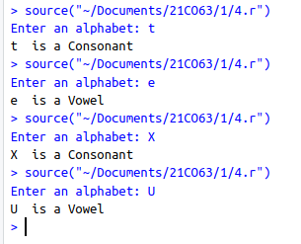

array = c(1, 2, 3, 4, 5, 6, 7, 8, 9, 10)

is_odd_even <- function(num) {

if (num %% 2 == 0) {

return("Even")

} else {

return("Odd")

}

}

for (num in array) {

cat("\nNumber", num, "is", is_odd_even(num))

}

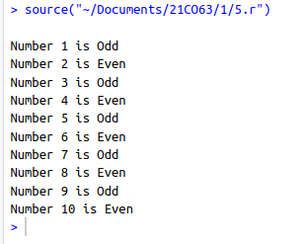

area_cir = function(r){

cat("\nArea of circle : ", 3.1413 * r * r)

}

area_rect = function(l, b){

cat("\nArea of Rectangle : ", l * b)

}

area_sqr = function(s){

cat("\nArea of Square : ", s * s)

}

area_cir(5)

area_rect(12, 3)

area_sqr(8)

compute_grade_percentage <- function() {

cat("Enter totals marks scored by the student :")

total_marks = as.integer(readline())

cat("Enter the number of subjects:")

subj = as.integer(readline())

percentage = (total_marks / (subj * 100)) * 100

if (percentage >= 90) {

grade = "A+"

} else if (percentage >= 80) {

grade = "A"

} else if (percentage >= 70) {

grade = "B"

} else if (percentage >= 60) {

grade = "C"

} else if (percentage >= 50) {

grade = "D"

} else {

grade = "F"

}

cat("Total Marks:", total_marks, "\n")

cat("Percentage:", percentage, "%\n")

cat("Grade:", grade, "\n")

}

compute_grade_percentage()

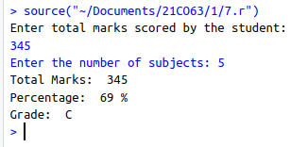

vec = c(4, 1, 5, 2, -3, 66, 323, 23, 534)

min = Inf

max = -Inf

for(i in vec){

if(min > i)

min = i

if(max < i)

max = i

}

cat("Vector : ", vec)

cat("\nMin : ", min, "\nMax : ", max)

